Security in Public Spaces Partnership: Roundtable held to validate the activities of action 1: Defining a framework to measure and assess security in cities

On Friday, 9th April, a virtual roundtable meeting was held in the framework of Action 1 of the Urban Agenda’s Security in Public Spaces Partnership. The event was attended by around 30 participants from various municipalities, police forces, international institutions and organisations. The roundtable showcased the progress made by the city of Helsinki and JRC with the support of the expert Simona Cavallini in developing a self-assessment tool to measure and assess security in cities. The roundtable comprised two sessions, whereby the first was dedicated to presenting highlights and main gaps of existing approaches and tools to measure security in European cities, and discussing a possible new and more comprehensive framework. The second session provided a space to debate on the operationalisation of the latter. The audience was involved in providing feedback on the core aspects and indicators of the presented framework through various live polls and designated discussion rounds.

Mapping existing indexes and developing a new framework to measure security
The aim of Action 1 is to provide cities of all sizes with a self-assessment tool which enables them to measure and assess their level of security. This exercise serves the ultimate purpose of assisting municipalities in establishing a baseline against which they can develop evidence-based urban security policies.

In developing the tool, the team working on Action 1 first set out to define all relevant terms to the area of urban security and the added value foreseen by such a tool. This was followed by a mapping exercise which took into account indexes focusing on structural monitoring tools in the area of safety and security from around the world, which had been developed within the past 10 years. Here, both successful and unsuccessful approaches were looked into, with a view to learning from their experiences. For each of those indexes, an analysis of the key components was conducted, covering what was measured, which methodology was used, what the purpose was, which types of data are used, and more. These insights were enriched with a survey which was shared among several cities within and outside the Partnership in spring 2021. The survey provided insights on experiences of urban authorities, and the gaps and criticalities they perceive in terms of measuring and assessing security.

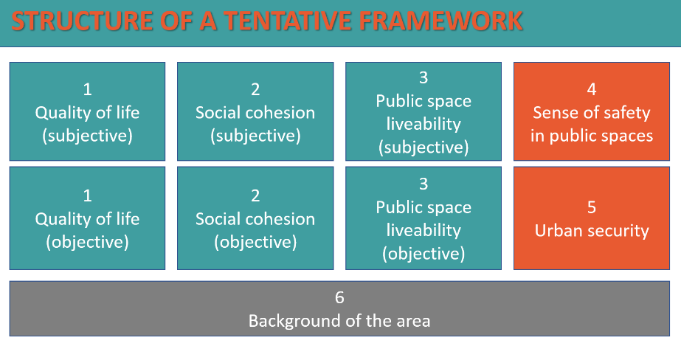
Preliminary structure of the framework presented during the Roundtable.

Based on the above, a holistic framework was built, which consists of 6 main components which are each informed by a range of indicators. During the first session of the roundtable, these components and their respective indicators were presented to the audience. Both the selection and definition of components were discussed, and participants provided feedback on each of the set of indicators, which served to validate the work that had been done and added to its completeness.

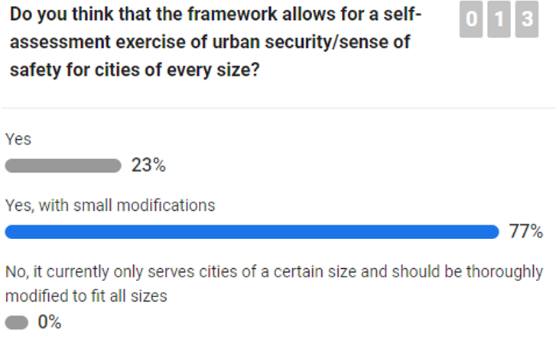
Audience feedback on the framework.

Operationalisation: Assisting urban authorities
The second part of the roundtable session focused on the operationalisation of the framework. Emphasis was placed during the discussion on ensuring that the tool would not provide administrations with additional burden, but rather, to enable them to conduct security assessments and measurements as efficiently and complete as possible. In practical terms, the tool provides municipalities with several sets of indicators which inform core aspects of urban security. Municipalities can use this as benchmark to compare already existing security assessment frameworks against, with a view to identifying whether there are any additional indicators which should be incorporated into existing assessment methods to create a more holistic assessment result. In the absence of existing security assessment frameworks, municipalities can use the framework as step by step guide to conduct such assessments in the first place. Here, the framework provides them with an overview of the indicators for which they should collect data.

Future steps
Following the roundtable and the feedback received, the team of Action 1 will continue to refine the framework and think about the best way to make it operational and easy to use for cities of different sizes. In the upcoming months, the study on existing approaches and indexes as well as the finalised framework will be made public. It is also intended that the latter will be tested by interested cities.

